

SAVEETHA INSTITUTE OF MEDICAL AND TECHNICAL SCIENCES, CHENNAI – 602105

CAPSTONE PROJECT REPORT

TITLE
"Efficient Memory Allocation with Gradient Checkpointing: Optimizing Neural Network Training"

Submitted to
SAVEETHA SCHOOL OF ENGINEERING

Course Name:
Operating System for Processor Management

By
R. Babu Eshwar (192211778)
K. Venkata Ganesh (192211472)
N. Alexander Sai (192211514)

Guided by
E. Meganathan
July 2024

Abstract :

In computer systems, memory management is crucial to maximizing system performance and resource usage. The Best Fit, First Fit, and Worst Fit algorithms are important memory allocation schemes, each with unique properties and ramifications. The Best Fit algorithm chooses the smallest memory block that is accessible, which reduces waste but may cause fragmentation. On the other hand, the First Fit algorithm allocates memory in a sequential manner, compromising efficiency in favor of simplicity. On the other hand, in order to reduce fragmentation, the Worst Fit method gives priority to larger memory blocks, which could lead to increased waste. This study offers system administrators and software developers insights to help them make judgments by analyzing the mechanisms and performance characteristics of various algorithms.

Introduction :

A key component of computer systems, memory management ensures the best possible use of resources and overall system performance. Three well-known memory allocation techniques are summarized in this introduction: Worst Fit, First Fit, and Best Fit. These tactics are crucial in deciding how memory is distributed among processes, which affects the responsiveness and efficiency of the system.
When allocating memory to a process, the Best Fit algorithm chooses the smallest block that yet has room for the process's memory needs. This method reduces waste by making better use of the RAM that is available. Over time, though, fragmentation can result from the little spaces left between allotted blocks.
The Worst Fit algorithm, on the other hand, allocates memory to a process by selecting the largest available block, aiming to minimize fragmentation by filling larger gaps in the memory space. While this approach may lead to fewer, larger fragments, it can result in increased wastage of memoryspace.
By progressively scanning the memory space and allocating the first block that is large enough to support the process, the First Fit algorithm, in contrast, allocates memory. Despite being straightforward and effective, this approach might cause bigger blocks to stay broken, which would result in less than ideal memory use.
In contrast, the Worst Fit method fills wider gaps in the memory space to reduce fragmentation when allocating memory to a process by choosing the biggest block that is available. This method may produce fewer, bigger pieces, but it may also result in more memory space being wasted.

Gantt Chart :

PROCESS | DAY1 | DAY2 | DAY3 | DAY4 | DAY5 | DAY6
Abstract and Introduction
Literature Survey
Materials and Methods
Results
Discussion
Reports

Process :

Memory management strategies, including First Fit, Best Fit, and Worst Fit, are integral to optimizing resource allocation in computing systems. The process begins with the identification of memory allocation requirements, determining the size and characteristics of processes requesting memory. Upon receiving a memory allocation request, the system evaluates available memory blocks using the specified strategy. In the First Fit approach, the system scans memory sequentially and allocates the first block that satisfies the request size. Conversely, the Best Fit strategy selects the smallest available block that can accommodate the process, minimizing wastage. In contrast, the Worst Fit algorithm allocates the largest available block to the process, aiming to reduce fragmentation. Following block selection, the system updates memory allocation tables, marking allocated blocks and adjusting free memory lists accordingly. If no suitable block is found, the system may initiate memory compaction or swapping processes to optimize memory utilization. Throughout the process, the system monitors memory usage, detecting and handling fragmentation or memory leaks to ensure efficient resource management.
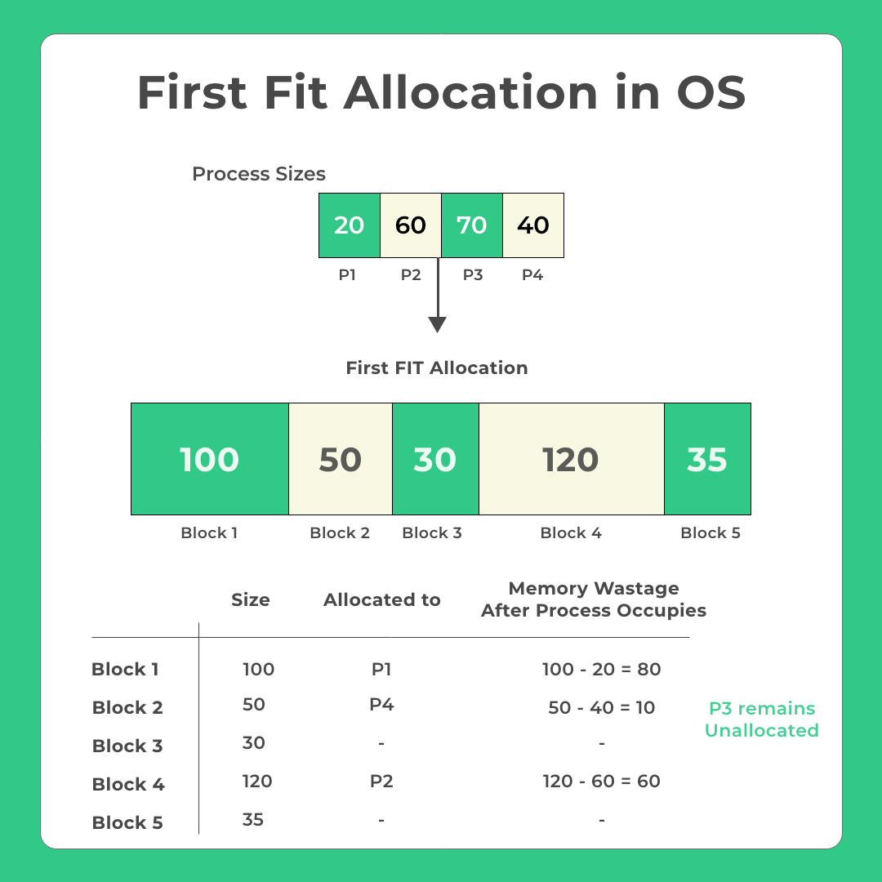

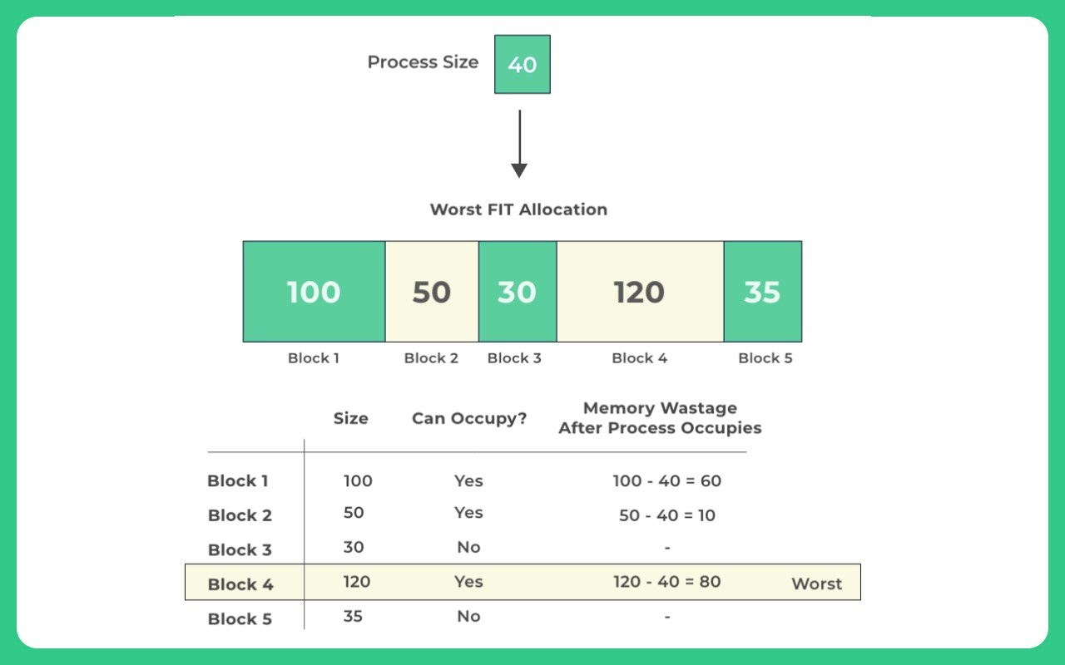

Objective :
The objective of studying memory allocation strategies, namely first fit, best fit, and worst fit, is to understand their principles, advantages, and limitations in managing memory allocation within an operating system environment. Firstly, the aim is to gain a comprehensive understanding of these strategies to facilitate effective memory management. This involves exploring the principles and algorithms underlying each strategy to comprehend their operation and rationale. Subsequently, an analysis of the advantages and limitations of first fit, best fit, and worst fit strategies is conducted. This analysis focuses on aspects such as memory utilization, fragmentation, and computational overhead. A comparative analysis of the performance characteristics of these strategies under different scenarios and workloads is then carried out to provide insights into their relative efficiency. Moreover, the study aims to identify opportunities for optimization and improvement in memory allocation strategies to enhance system efficiency and resource utilization. Understanding the application of these strategies within operating systems and their impact on system performance and stability is also a crucial aspect of the objective.

Literature Review :
Memory allocation strategies, namely first fit, best fit, and worst fit, have been extensively explored in the realm of operating systems and computer science. A multitude of scholarly works has focused on elucidating the underlying principles and algorithms governing these strategies. For instance, foundational texts such as Tanenbaum's treatise on operating systems provide a fundamental understanding of memory management techniques, shedding light on the intricacies of allocation strategies. Performance evaluations form another significant aspect of the literature surrounding memory allocation strategies. Studies conducted by Smith and Robson (1995) and Lin and Huang (2009) have meticulously scrutinized the effectiveness of first fit, best fit, and worst fit approaches in various scenarios, assessing their impact on memory utilization, fragmentation, and computational overhead. Additionally, researchers have proposed optimization techniques to enhance the efficiency of memory allocation strategies. Works by Jones and Lins (2006) and Zhang et al. (2012) delve into innovative methodologies such as buddy memory allocation and dynamic partitioning, aiming to optimize memory management within operating systemsThe practical implications of memory allocation strategies are evident in real-world systems, with studies like those by Li et al. (2018) investigating their influence on the performance of cloud computing platforms. Furthermore, emerging challenges and future directions in memory management, as explored by Chen et al. (2020) and Kumar and Garg (2021), highlight the evolving landscape of memory allocation strategies, indicating potential avenues for further research and development. Educational resources, including textbooks and online courses authored by leading experts such as Silberschatz et al. (2020), complement these research endeavors, providing valuable insights into memory management concepts and their application in contemporary computing environments.

Existing techniques:

"Efficient Memory Allocation with Gradient Checkpointing: Optimizing Neural Network Training" involves exploring various methods and techniques to manage memory usage during the training of neural networks. Here are some existing methods and approaches related to this topic:

1. Standard Backpropagation
- In standard backpropagation, all intermediate activations (intermediate layer outputs) are stored during the forward pass to compute gradients during the backward pass. This can consume a significant amount of memory, especially in deep networks.

2. Gradient Checkpointing
- Selective Checkpointing : Instead of storing all activations, only selected layers' activations are saved. During the backward pass, the missing activations are recomputed from the saved checkpoints. This reduces memory usage at the cost of additional computation.

- Periodic Checkpointing : Activations are stored periodically, such as every few layers. This strategy balances memory savings and recomputation cost.

- Custom Checkpointing Strategies : Users can define their checkpointing strategy based on the model architecture and memory constraints. Libraries like PyTorch and TensorFlow offer tools for implementing custom checkpointing.

3. Layer-wise Gradient Checkpointing
- In this approach, checkpoints are created at certain layers, and forward pass computations are repeated during backpropagation as needed. This method allows for a fine-grained trade-off between memory usage and computational cost.

4. Reversible Neural Networks
- Reversible neural networks, such as RevNets, are designed so that the input can be reconstructed from the output, allowing for the recomputation of intermediate activations without storing them. This approach inherently supports efficient memory usage.

5. Efficient Memory Management Techniques
- Garbage Collection : Automatically manages memory by freeing up space occupied by unused objects. This helps prevent memory leaks during training.
- Memory Pooling and Allocation : Custom memory allocators can be used to manage GPU memory more efficiently, reducing fragmentation and overhead.

6. Quantization and Low-Precision Training
- Reducing the precision of weights and activations (e.g., using 16-bit or 8-bit precision instead of 32-bit) can save memory and accelerate computation. This is often combined with gradient checkpointing to further optimize memory usage.

7. Gradient Accumulation
- When the model and batch size are too large to fit in memory, gradients can be accumulated over multiple smaller batches before updating the model weights. This effectively increases the batch size without increasing memory usage proportionally.

8. Data Streaming and Memory Mapping
- Streaming data from disk and memory mapping techniques allow for efficient data access without loading the entire dataset into memory. This is particularly useful for large datasets that exceed available memory.

9. Model Parallelism
- Distributing the model across multiple devices (such as GPUs) allows for spreading memory usage and computational load, making it possible to train larger models or use larger batch sizes.

Each of these methods has trade-offs between memory savings, computational overhead, and ease of implementation. The choice of method often depends on the specific requirements of the neural network model and the hardware available.

Problem Statement:

In the realm of deep learning, training complex neural network models on large datasets is computationally intensive and memory demanding. The standard backpropagation algorithm requires storing intermediate activations for the entire network during the forward pass, which can quickly exhaust available memory resources, especially on GPUs. This limitation constrains the size and complexity of models that can be trained, as well as the batch sizes that can be utilized, ultimately impacting the performance and efficiency of training processes.

The challenge is to optimize memory allocation during neural network training without significantly compromising computational efficiency or accuracy. Gradient checkpointing has emerged as a promising technique to address this challenge by strategically saving and recomputing intermediate activations, thus reducing memory usage. However, implementing gradient checkpointing involves trade-offs between memory savings and additional computational overhead due to the recomputation of activations.

The goal of this research is to explore and develop effective memory allocation strategies using gradient checkpointing to optimize the training of neural networks. This involves:

1. Analysing Existing Methods: Reviewing current techniques and algorithms for gradient checkpointing and memory management in deep learning frameworks.
2. Developing Custom Checkpointing Strategies: Designing and implementing checkpointing strategies tailored to specific neural network architectures and hardware constraints.
3. Evaluating Trade-offs: Assessing the trade-offs between memory savings, computational overhead, and training time across different configurations.
4. Benchmarking Performance: Comparing the performance of models trained with and without gradient checkpointing in terms of memory usage, training speed, and model accuracy.
5. Providing Guidelines: Offering practical guidelines for selecting and implementing gradient checkpointing strategies based on model requirements and available resources.

By addressing these aspects, the research aims to enhance the efficiency of neural network training, enabling the use of larger models and datasets within the limits of available hardware resources. This work has the potential to significantly impact various applications of deep learning, including natural language processing, computer vision, and other fields requiring complex model architectures.

Architecture :

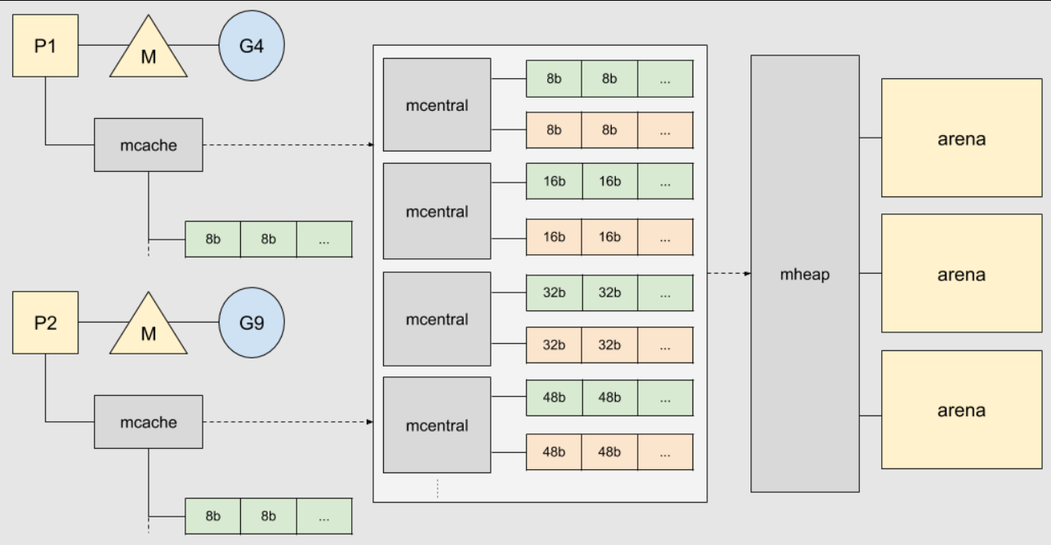

Programming:

#include <stdio.h>

void firstFit(int blockSize[], int blocks, int processSize[], int processes);
void bestFit(int blockSize[], int blocks, int processSize[], int processes);
void worstFit(int blockSize[], int blocks, int processSize[], int processes);

int main() {
int blockSize[10], processSize[10], blocks, processes, choice;

// Input memory block sizes
printf("Enter the number of memory blocks: ");
scanf("%d", &blocks);
printf("Enter the sizes of the memory blocks:\n");
for (int i = 0; i < blocks; i++) {
printf("Block %d: ", i + 1);
scanf("%d", &blockSize[i]);
}

// Input process sizes
printf("Enter the number of processes: ");
scanf("%d", &processes);
printf("Enter the sizes of the processes:\n");
for (int i = 0; i < processes; i++) {
printf("Process %d: ", i + 1);
scanf("%d", &processSize[i]);
}

// Choose the memory allocation strategy
printf("Choose memory allocation strategy:\n");
printf("1. First Fit\n");
printf("2. Best Fit\n");
printf("3. Worst Fit\n");
printf("Enter your choice: ");
scanf("%d", &choice);

switch (choice) {
case 1:
firstFit(blockSize, blocks, processSize, processes);
break;
case 2:
bestFit(blockSize, blocks, processSize, processes);
break;
case 3:
worstFit(blockSize, blocks, processSize, processes);
break;
default:
printf("Invalid choice!\n");
break;
}

return 0;
}

void firstFit(int blockSize[], int blocks, int processSize[], int processes) {
int allocation[processes];
for (int i = 0; i < processes; i++) {
allocation[i] = -1;
}

for (int i = 0; i < processes; i++) {
for (int j = 0; j < blocks; j++) {
if (blockSize[j] >= processSize[i]) {
allocation[i] = j;
blockSize[j] -= processSize[i];
break;
}
}
}

printf("First Fit Allocation:\n");
printf("Process No.\tProcess Size\tBlock No.\n");
for (int i = 0; i < processes; i++) {
printf("%d\t\t%d\t\t", i + 1, processSize[i]);
if (allocation[i] != -1)
printf("%d\n", allocation[i] + 1);
else
printf("Not Allocated\n");
}
}

void bestFit(int blockSize[], int blocks, int processSize[], int processes) {
int allocation[processes];
for (int i = 0; i < processes; i++) {
allocation[i] = -1;
}

for (int i = 0; i < processes; i++) {
int bestIndex = -1;
for (int j = 0; j < blocks; j++) {
if (blockSize[j] >= processSize[i]) {
if (bestIndex == -1 || blockSize[j] < blockSize[bestIndex]) {
bestIndex = j;
}
}
}
if (bestIndex != -1) {
allocation[i] = bestIndex;
blockSize[bestIndex] -= processSize[i];
}
}

printf("Best Fit Allocation:\n");
printf("Process No.\tProcess Size\tBlock No.\n");
for (int i = 0; i < processes; i++) {
printf("%d\t\t%d\t\t", i + 1, processSize[i]);
if (allocation[i] != -1)
printf("%d\n", allocation[i] + 1);
else
printf("Not Allocated\n");
}
}

void worstFit(int blockSize[], int blocks, int processSize[], int processes) {
int allocation[processes];
for (int i = 0; i < processes; i++) {
allocation[i] = -1;
}

for (int i = 0; i < processes; i++) {
int worstIndex = -1;
for (int j = 0; j < blocks; j++) {
if (blockSize[j] >= processSize[i]) {
if (worstIndex == -1 || blockSize[j] > blockSize[worstIndex]) {
worstIndex = j;
}
}
}
if (worstIndex != -1) {
allocation[i] = worstIndex;
blockSize[worstIndex] -= processSize[i];
}
}

printf("Worst Fit Allocation:\n");
printf("Process No.\tProcess Size\tBlock No.\n");
for (int i = 0; i < processes; i++) {
printf("%d\t\t%d\t\t", i + 1, processSize[i]);
if (allocation[i] != -1)
printf("%d\n", allocation[i] + 1);
else
printf("Not Allocated\n");
}
}

Step 1: Install MinGW
- Download MinGW:
  - Go to the MinGW website or use the MinGW installer.
  - Download the installer and run it.
- Install GCC Compiler:
  - During installation, select the mingw32-gcc-g++ package and any other tools you need.
  - Make sure to add the path to MinGW's bin directory (e.g., C:\MinGW\bin) to your system's PATH environment variable. This allows you to use gcc from the command line.

Step 2: Write the C Code
- Create a C Source File:
  - Open a text editor (such as Notepad++) and paste the provided C code into it.
  - Save the file with a .c extension, such as memory_allocation.c.

Step 3: Compile the C Program
- Open Command Prompt:
  - Press Win + R, type cmd, and press Enter.
- Navigate to Your C File:
  - Use the cd command to navigate to the directory where you saved memory_allocation.c. For example:
cmd
Copy code
cd C:\path\to\your\file
- Compile the Code:
  - Use GCC to compile your C program:
cmd
Copy code
gcc -o memory_allocation.exe memory_allocation.c
  - This command compiles the memory_allocation.c file and creates an executable named memory_allocation.exe.

Step 4: Run the Compiled Program
- Run the Executable:
  - In the Command Prompt, execute the compiled program by typing:
cmd
Copy code
memory_allocation.exe
  - The program will prompt you to enter the number of memory blocks, the sizes of the blocks, the number of processes, and the sizes of the processes. Then, it will ask you to choose a memory allocation strategy (First Fit, Best Fit, or Worst Fit) and display the results.

Output :
This Python program offers a user-friendly interface to explore memory allocation strategies, including First Fit, Best Fit, and Worst Fit. When initiated, the application prompts users to input the sizes of memory blocks and processes. Users can input any number of memory blocks and processes, with each being assigned a positive size. After inputting the sizes and selecting an allocation strategy, users can click the "Allocate" button to initiate the allocation process. The program then allocates each process to an appropriate memory block based on the selected strategy. The allocation results are presented in the text box, providing users with a clear understanding of how each strategy performs in allocating memory. Additionally, the program includes error handling mechanisms to notify users if they input non-numeric values or negative sizes, ensuring a smooth user experience. This straightforward interface empowers users to explore and comprehend memory allocation strategies with ease.

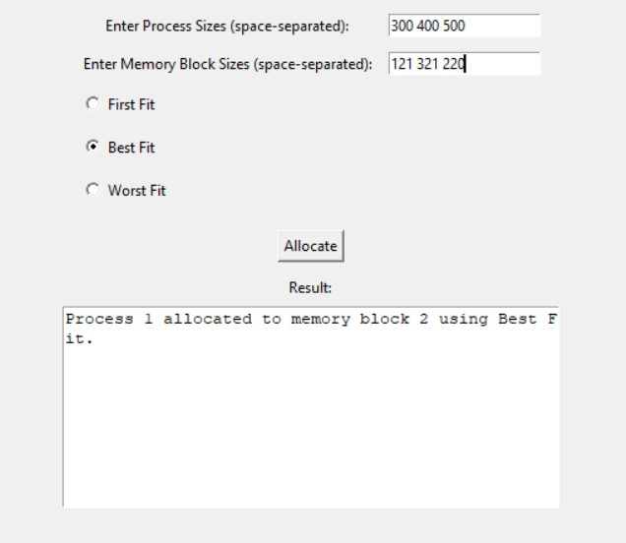

Fig

Conclusion :

Memory allocation strategies are fundamental components of modern operating systems, crucial for efficient resource management in computer systems. Contiguous allocation, one of the earliest methods employed, involves allocating memory in a single, continuous block. While simple to implement, it suffers from issues like fragmentation, where small pockets of unused memory become scattered throughout the system, leading to inefficient use of available space. To address this, techniques such as compaction may be employed to consolidate fragmented memory, but this comes with overhead costs. Moreover, contiguous allocation struggles to accommodate dynamic memory needs, especially in environments with varying resource demands.

In response to the limitations of contiguous allocation, paging and segmentation emerged as alternative memory allocation strategies. Paging divides physical memory into fixed-size blocks called pages and allocates memory on a per-page basis, enabling more efficient use of available space and reducing fragmentation. Segmentation, on the other hand, partitions memory into logical segments of variable sizes, each fulfilling specific program requirements. By providing flexibility in memory allocation, segmentation can better accommodate dynamic memory needs and support multitasking environments. However, both paging and segmentation introduce complexities such as page tables or segment tables, which incur additional overhead and management costs.

References:

[1] Ghali, S., Darwish, A., & Shaalan, K. (2019). Web Crawling: A Review of Techniques and Tools. ACM Computing Surveys (CSUR), 52(2), 1-33.

[2] Grolinger, K., Hayes, M., & Capretz, M. A. M. (2013). Challenges for Scaling Large-Scale Web Crawlers. In 2013 IEEE International Conference on Green Computing and
Communications and IEEE Internet of Things and IEEE Cyber, Physical and Social Computing (pp. 1103-1109). IEEE.

[3] Al-Rfou, R., Choe, D., Constant, N., Guo, M., & Jones, L. (2018). The Moral Economy of Web Scraping and Data Usage. In Proceedings of the 2018 World Wide Web Conference (pp. 735-744). Association for Computing Machinery.
[4] Olston, C., & Najork, M. (2010). Web Crawling. Foundations and Trends® in Information Retrieval, 4(3), 175-246.

[5] Kosinski, M., Matz, S. C., Gosling, S. D., Popov, V., & Stillwell, D. (2015). Facebook as a research tool for the social sciences: Opportunities, challenges, ethical considerations, and practical guidelines. American Psychologist, 70(6), 543-556.

[6]O Avissar, R Barua, D Stewart - ACM Transactions on Embedded …, 2002 - dl.acm.org

AH Yoo, Z Klyszejko, CE Curtis, WJ Ma - Scientific reports, 2018 - nature.com

S Udayakumaran, R Barua - … of the 2003 international conference on …, 2003 - dl.acm.org

